**AUTOMATED ATTENDANCE PORTAL-USING RFID AND FACE RECOGNITION**

SUBMITTED IN PARTIAL FULFILLMENT FOR THE REQUIREMENT OF THE AWARD OF DEGREE OF

**BACHELOR OF TECHNOLOGY**

**IN**

**COMPUTER SCIENCE**



Submitted by

ANAND PARASHAR (2000290120023)

ANTRIKSH TYAGI (2100290129004)

DEVRAJ GUPTA (2000290120062)

ANSH SRIVASTAVA (2000290120028)

.

Supervised by

MR. ANMOL JAIN

(ASST.PROF)

**Session 2023-24**

DEPARTMENT OF COMPUTER SCIENCE

**KIET GROUP OF INSTITUTIONS, GHAZIABAD**

**AFFIL…**

**(Affiliated to Dr. A. P. J. Abdul Kalam Technical University, Lucknow, U.P., India)**

**DECLARATION**

We hereby declare that this submission is our own work and that, to the best of our knowledge and belief, it contains no material previously published or written by another person nor material which to a substantial extent has been accepted for the award of any other degree or diploma of the university or other institute of higher learning, except where due acknowledgment has been made in the text.

Signature of Student

**Name: - Anand Parashar (**

**Roll No.: - 2000290120023**

**Name: - Antriksh Tyagi**

**Roll No.: - 2100290129004**

**Name: - Devraj Gupta**

**Roll No.: - 2000290120062**

**Name: - Ansh Srivastava**

**Roll No.: - 2000290120028**

**Date: -07-05-2024**

## **CERTIFICATE**

This is to certify that Project Report entitled “Automated Attendance Portal: Using RFID and Facial recognition” which is submitted by **Anand Parashar, Antriksh Tyagi, Devraj Gupta, Ansh Srivastava** in partial fulfillment of the requirement for the award of degree B. Tech. in Department of Computer Science of KIET GROUPOG Dr. A.P.J. Abdul Kalam Technical University, Lucknow is a record of the candidates own work carried out by them under my supervision. The matter embodied in this report is original and has not been submitted for the award of any other degree.

.

**Date: 07-05-2024**

**PROF.ANMOL JAIN**

(Assistant Professor, CS)

**ACKNOWLEDGEMENT**

It gives us a great sense of pleasure to present the report of the B. Tech Project undertaken during B. Tech. Final Year. We owe special debt of gratitude to MR. Anmol Jain (Asst. Prof.), Department of Computer Science, KIET GGGGG, Ghaziabad, for his constant support and guidance throughout the course of our work. His sincerity, thoroughness and perseverance have been a constant source of inspiration for us. It is only his cognizant efforts that our endeavors have seen light of the day.

We also take the opportunity to acknowledge the contribution of **Dr. Ajay Kumar Shrivastava**, Head of the Department of Computer Science, KIET, Ghaziabad, for his full support and assistance during the development of the project. We also do not like to miss the opportunity to acknowledge the contribution of all the faculty members of the department for their kind assistance and cooperation during the development of our project.

Last but not the least, we acknowledge our family and friends for their contribution in the completion of the project.

Date :

Signature: Signature:

Name : ANAND PARASHAR Name: ANTRIKSH TYAGI

Roll No.: 2000290120023 Roll No.:2100290129004

Signature: Signature:

Name : DEVRAJ GUPTA Name: ANSH SRIVASTAVA

Roll No.: 2000290120062 Roll No.: 1102912067

**ABSTRACT**

The management of the attendance can be a great burden on the teachers if it is done by hand. To resolve this problem, a smart and auto attendance management system is being utilized. But authentication is an important issue in this system. The smart attendance system is generally executed with the help of biometrics. Face recognition is one of the biometric methods to improve this system. Being a prime feature of biometric verification, facial recognition is being used enormously in several such applications, like video monitoring and CCTV footage system, an interaction between computer & humans and access systems presents indoors and network security. By utilizing this framework, the problem of proxies and students being marked present even though they are not physically present can easily be solved. The main implementation steps used in this type of system are face detection and recognizing the detected face.

Automatic face recognition (AFR) technologies have made many improvements in the changing world. Smart Attendance using Real-Time Face Recognition is a real-world solution which comes with day-to-day activities of handling student attendance system.

Face recognition-based attendance system is a process of recognizing the students face for taking attendance by using face biometrics based on high - definition monitor video and other information technology.

It helps in conversion of the frames of the video into images so that the face of the student can be easily recognized for their attendance so that the attendance database can be easily reflected automatically.

This paper proposes a model for implementing an automated attendance management system for students of a class by making use of face recognition technique, by using Eigenface values, Principle Component Analysis (PCA) and Local Binary Patterns Histograms (LBPH) algorithm. After these, the connection of recognized faces ought to be conceivable by comparing with the database containing student's faces. This model will be a successful technique to manage the attendance and records of students.

|  |  |
| --- | --- |
| **TABLE OF CONTENTS** | **Page No.** |
| DECLARATION……………………………………………………………………. | ii |
| CERTIFICATE……………………………………………………………………… | iii |
| ACKNOWLEDGEMENTS…………………………………………………………. | iv |
| ABSTRACT……………………………………………………………………….... | v |
| LIST OF FIGURES…………………………………………………………………. | ix |
| LIST OF TABLES…………………………………………………………………… | xi |
| LIST OF ABBREVIATIONS………………………………………………………. | xii |
|  |  |
| CHAPTER 1 INTRODUCTION PAGE NO.  1.1 INTRODUCTION TO PROJECT  1.2 Project Category (Internet Based, Application Or SYSTEM DEVELOPMENT, RESEARCH BASED ,INDUSTRY AUTOMATION, NETWORK OR SYSTEM ADMINISTRATION)  1.3 OBJECTIVES  1.4 Problem FormulatioN  1.5 PROPOSED SYSTEM  1.6 UNIQUE FEATURES OF THE SYSTEM  CHAPTER 2. REQUIREMENT ANALYSIS AND SYSTEM SPECIFICATION  2.1 FEASIBILITY STUDY (TECHNICAL, ECONOMICAL, OPERATIONAL)  2.2 SOFTWARE REQUIREMENT SPECIFICATION DOCUMENT WHICH MUST INCLUDE THE FOLLOWING:  (DATA REQUIREMENT, FUNCTIONAL REQUIREMENT, PERFORMANCE REQUIREMENT  , MAINTAINABILITY REQUIREMENT, SECURITY REQUIREMENT)  2.3 SDLC MODEL TO BE USED  CHAPTER 3. SYSTEM DESIGN  3.1 DETAIL DESIGN  3.2 SYSTEM DESIGN USING DFD LEVEL 0, LEVEL1, LEVEL 2, LEVEL 3, LEVEL 4.  3.3 USE CASE DIAGRAM  3.4 DATABASE DESIGN  3.4.1 ER DIAGRAMS    CHAPTER 4. IMPLEMENTATION, TESTING, AND MAINTENANCE  4.1 INTRODUCTION TO LANGUAGES, TOOLS AND TECHNOLOGIES USED FOR IMPLEMENTATION  4.2 TESTING TECHNIQUES AND TEST CASES USED  CHAPTER 5. RESULTS AND DISCUSSIONS  5.1 USER INTERFACE REPRESENTATION (OF RESPECTIVE PROJECT)  5.1.1 BRIEF DESCRIPTION OF VARIOUS MODULES OF THE SYSTEM  5.2 SNAPSHOTS OF SYSTEM WITH BRIEF DETAIL OF EACH  5.3 BACK-ENDS REPRESENTATION (DATABASE TO BE USED)  5.3.1 SNAPSHOTS OF DATABASE TABLES WITH BRIEF DESCRIPTION  CHAPTER 6. CONCLUSION AND FUTURE SCOPE  REFERENCES (REFERENCES SHOULD BE IN IEEE STANDARD) |  |

**CHAPTER-1**

**INTRODUCTION**

1.1 Introduction

**justify**

Attendance systems of old practices are not quite efficient. now a days for keeping track on student’s attendance. Student enrollment in schools and colleges is increasing every year and each student’s attendance plays a very important role. So, it is necessary to discuss an effective system which records the attendance of a student automatically. Maintaining attendance is very important in all the colleges for checking the performance of students. Every college has its own method in this regard. Some are taking attendance of students manually using attendance registers or marking attendance sheets or file-based approach and some have adopted the methods of automatic attendance using some biometric techniques. But in these methods, students must wait for a long time in a queue at the time they enter inside the classroom.

Many biometric systems are available in the market, but the key authentications are the same in all the techniques. Every biometric system consists of an enrollment process in which the unique feature of a person is stored in the database and after that, there are some processes of identification and verification of the person. These two processes compare the biometric features of a person with previously stored template captured at the time of enrolment of a student. Biometric templates can be of many types like Fingerprints, Eye Iris, voice etc. Our system uses the face recognition approach for the automatic attendance of the students in the classroom environment without student intervention. The purpose of developing the new attendance management system is to computerize the traditional methods of taking the attendance. Therefore, to draw the attention of students and make them interactive in observing technologies, we try to move on to the latest upcoming trends in developing attendance systems. This is the reason for the college attendance management system to come up with an approach that ensures a strong contribution of students in classrooms.

To track the attendance of the students, we have introduced the attendance management system. With the introduction of this attendance system, skipping classes for students without the staff’s knowledge has become difficult. The attendance management system is to count the number of students and urge students to attend the classes on time, so as to improve the quality of teaching.

**1.2 PROJECT CATEGORY**

**Project Category: System Development/Application Development**

1. **System Development:**
   * The project involves the development of a comprehensive system for managing student attendance.
   * This includes designing and implementing various software components to facilitate attendance recording, tracking, and reporting.
2. **Application Development:**
   * The core focus of the project is to create a software application tailored specifically for managing attendance within educational institutions.
   * This application will likely include a user-friendly interface accessible to teachers and administrators for inputting and accessing attendance data.
   * Additionally, the application will involve backend development to handle data storage, processing, and management.

**Reasoning:**

* The project revolves around developing a software solution to address a specific need: managing student attendance efficiently.
* While internet-based technologies may be used for certain functionalities (such as remote access or cloud storage), the primary objective is not centred around internet-based services.
* Research-based projects typically involve conducting extensive research to explore new concepts, theories, or technologies. While the project may involve some research into existing attendance management systems and best practices, it is primarily focused on implementing a functional solution rather than advancing theoretical knowledge.
* Industry automation projects typically involve automating specific tasks or processes within industries to improve efficiency or productivity. While the attendance management system could enhance efficiency within educational institutions, it is not primarily focused on industrial automation.
* Network or system administration projects involve managing and maintaining computer networks or systems. While the attendance management system may require considerations for network infrastructure and system requirements, its primary focus is on software development rather than network/system administration.

**1.3 OBJECTIVES**

As we aim to build an automated attendance portal which is on web version to automate the attendance through face recognition. Objectives are as follows-

1. Develop a Robust Face Recognition System.
2. Integrate Face Recognition with PHP Backend.
3. Automate Attendance Tracking Process
4. Ensure Data Security and Privacy.
5. Provide User-Friendly Interface.
6. Support Scalability and Customization.
7. Facilitate Integration with Existing Systems.
8. Ensure Accessibility and Usability.

**1.4 PROBLEM FORMULATION**

When there are so many students in a college, it becomes more and more difficult to mark attendance for each student and it is time consuming too. The Existing system of any institute is a manual entry for the students. This system faces the issue of wastage of time and becomes complicated when the strength is more than usual. Here, the attendance is being carried out in the handwritten registers. It is a very tedious job for us to maintain the record of the user.

Whenever we must measure the performance of students, finding and calculating the average attendance of each enrolled student is also a very complicated task for us. Human effort is more here. The retrieval of the information is not a piece of cake as the records are maintained in the handwritten registers. This existing system requires correct feed on input into the respective field. Therefore, we need an automated system for marking and maintaining attendance of the students. Let us suppose that the wrong inputs are entered, the application resist to work. So, the user finds it difficult to use the existing system.

**1.5 PROPOSED SYSTEM//METHODOLOGY**

In our proposed system, the system is instantiated by the mobile. After it triggers then the system starts processing the image of the students for which we want to mark the attendance.

Image Capturing phase is one in which we capture the image of the students. This is the very basic phase from which we start initializing our system. We capture an image from our camera which predominantly checks for certain constraints like lightning, spacing, density, facial expressions etc. The captured image is resolute according to our requirements. Once it is resolute, we make sure it is either in .png or .jpeg format.

We take different frontal postures of an individual so that accuracy can be attained to the maximum extent. This is the training database in which we classify every individual based on labels. For the captured image, from every object we detect only frontal faces. This detects only face and removes every other part since we are exploring the features of

faces only. These detected faces are stored somewhere in the database for further enquiry. Features are extracted in the extraction phase.

The detected bounding boxes are further queried to look for features extraction and the extracted features are stored in a matrix. For every detected phase, this feature extraction is done. Features that we look here are shape, edge, color, auto-correlation, and LBP. Face is recognized once we complete the extracting features. The features which are already trained with every individual is compared with the detected faces features and if both features match, then it is recognized. Once it recognizes, it is going to update in the student attendance database. Once the process is completed, the testing images remain.

Usually, a roll no. call is taken to determine whether the student is present in the class or not, which usually wastes a lot of time. In recent years, with the emerging technology and with the development of deep learning, face recognition has made great achievements, which leads us to a new way of thinking to solve the problem of student enrollment. So, to save time, the idea to count the number of students in a class automatically based on face recognition is incorporated. This system is developed by using face recognition technique which is used to detect the face of an individual. There are many different face recognition algorithms introduced to increase the efficiency of the system. The system provides an increased accuracy due to the use of many features like Shape, color, LBP [11], Auto- Correlation etc. of the face. However, face recognition remains a challenging problem for us because of its fundamental difficulties regarding various factors like illumination changes, face rotation, facial expression etc.

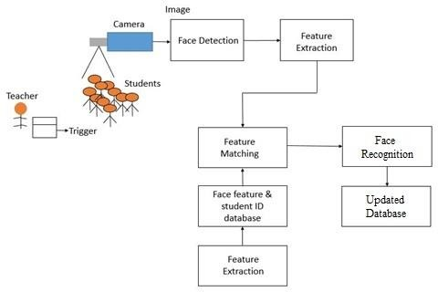

fignnn **System Model of face detection & recognition**

**1.6 UNIQUE FEATURES**

The attendance management system presented in this project incorporates several unique features that set it apart from traditional methods of attendance tracking. Some of these distinctive features include: -

* **RFID Integration:** The system utilizes RFID technology to streamline the attendance recording process. Each student is issued an RFID card or tag, which they can scan upon entering the classroom to mark their attendance automatically.
* **Biometric Recognition:** In addition to RFID scanning, the system may also support biometric recognition methods such as fingerprint or facial recognition. This provides an additional layer of security and ensures that attendance records are accurate and tamper-proof.
* **Real-Time Data Updates**: Attendance data is updated in real-time, allowing teachers and administrators to access the latest attendance information instantly. This ensures that educators have timely insights into student attendance patterns and can take appropriate action as needed.
* **Customizable Reporting:** The system offers customizable reporting and analytics tools, allowing educators to generate detailed attendance reports tailored to their specific requirements. This enables them to analyze attendance trends, identify patterns, and make data-driven decisions to improve student outcomes.
* **Automated Notifications**: The system can send automated notifications to students, parents, and teachers regarding attendance-related matters. This may include notifications for absentees, late arrivals, or unauthorized absences, helping to improve communication and accountability.
* **Integration with Learning Management Systems (LMS):** The system may integrate seamlessly with existing learning management systems used by educational institutions. This allows for the seamless exchange of data between the attendance management system and other educational platforms, streamlining administrative processes.
* **Scalability and Customization:** The system is designed to be scalable and customizable to meet the unique needs of different educational institutions. Whether managing attendance for a small classroom or a large university campus, the system can adapt to accommodate varying class sizes, schedules, and attendance policies.

**CHAPTER 2**

**Requirement Analysis and System Specifications**

**2.1 Feasibility study (**TECHNICAL, ECONOMICAL, OPERATIONAL)

TECHNICAL Feasibility Study-

**a) Hardware Requirements:**

* Desktop, CPU (Normal computer system), RFID Scanner(optional).

b) **Software requirements:**

* Programming languages (Python, PHP).
* Frameworks and Libraries (Open CV, Python libraries (requests, NumPy, datetime, Serial)),
* Database management (My SQL),
* Integrated Development Environment (Visual Studio Code)
* Virtual environment (Anaconda Navigator (Anaconda 3))
* XAMPP (For testing of PHP backend and MySQL database)
* Apache HTTP server (for hosting the PHP based backend and serving web pages to clients)

c**) Scalability:**

* Increase in Users: As more teachers and administrative staff members use the system to manage attendance for various classes and subjects, the number of concurrent users accessing the system may increase. The system is designed to accommodate this growth in user activity without experiencing slowdowns or performance issues.
* Data Volume: Over time, the attendance management system will accumulate a large volume of attendance records for multiple classes, subjects, and students. The system's database can efficiently store and retrieve this data, even as it grows in size. Additionally, the system supports efficient data processing and analysis to generate reports and insights from the attendance data.
* Load Balancing: To ensure scalability, the system can implement load balancing techniques to distribute incoming user requests evenly across multiple servers or resources. This helps prevent any single server from becoming overwhelmed with requests and ensures consistent performance for all users.
* Resource Allocation: The system can dynamically allocate resources such as CPU, memory, and storage based on the current workload and demand. This ensures optimal utilization of resources and prevents bottlenecks that could hinder system performance during peak usage periods.

**d)Integration:**

In this project all PHP units are easily integrable because of viewability and intractability of all units of software. The routes of all PHP pages must be predefined to understand the workflow of the website.

OPERATIONAL Feasibility:

1. **User Acceptance**:
   * Teachers: Determine if teachers are willing to adopt the attendance management system as part of their daily routine. This involves understanding their attitudes towards technology adoption, their perceived benefits of using the system, and addressing any concerns they may have regarding its implementation.
   * Administrators: Assess the willingness of school administrators to support the deployment and maintenance of the system. This includes evaluating their understanding of the system's functionalities, their expectations regarding its impact on administrative tasks, and their commitment to providing necessary resources for its successful implementation.
   * Other Stakeholders: Consider the perspectives of other stakeholders such as students, parents, and regulatory bodies. Understand their expectations, concerns, and requirements regarding attendance tracking and reporting.
2. **Training Needs**:
   * Teachers: Identify the training requirements for teachers to effectively use the attendance management system. This may include training sessions on system navigation, data entry, attendance recording procedures, and troubleshooting common issues.
   * Administrators: Determine the training needs for school administrators responsible for managing user accounts, configuring system settings, generating reports, and addressing technical issues. Provide comprehensive training programs to ensure administrators can fulfil their roles effectively.
   * Technical Support: Establish a support mechanism to address user queries, provide technical assistance, and offer ongoing training and guidance as needed.
3. **Legal and Regulatory Compliance**:
   * Data Privacy: Ensure that the attendance management system complies with relevant data privacy laws and regulations, such as the General Data Protection Regulation (GDPR) or the Family Educational Rights and Privacy Act (FERPA). Implement robust data protection measures, including encryption, access controls, and user consent mechanisms, to safeguard sensitive attendance information.
   * Security: Implement security measures to protect the system from unauthorized access, data breaches, and cyber threats. This includes regular security audits, vulnerability assessments, and adherence to industry best practices for secure software development.
   * Attendance Tracking Regulations: Ensure that the system adheres to local educational regulations and institutional policies regarding attendance tracking, reporting, and record-keeping. This may include compliance with government-mandated attendance requirements, accreditation standards, and audit procedures.
4. **Ease of Use**:
   * User Interface Design: Design an intuitive and user-friendly interface that simplifies attendance tracking and reporting tasks for teachers, administrators, and other stakeholders. Incorporate features such as clear navigation menus, interactive dashboards, and customizable views to enhance usability.
   * Mobile Accessibility: Ensure that the system is accessible from a variety of devices, including desktop computers, laptops, tablets, and smartphones. Develop responsive web interfaces and native mobile applications that adapt to different screen sizes and input methods, allowing users to access attendance data anytime, anywhere.
   * User Feedback: Gather feedback from users through surveys, focus groups, and usability testing sessions to identify areas for improvement and refine the system's usability over time. Incorporate user feedback into iterative design updates and continuous improvement processes to enhance user satisfaction and adoption rates.

**2.2 SOFTWARE REQUIREMENT SPECIFICATION**

**1. Data Requirement:**

* Student Information: The system requires a database to store student information, including roll numbers, names, and optionally, photographs.
* Class Information: Information about classes, such as class names and subjects, needs to be stored for attendance tracking.
* Attendance Records: The system must maintain records of student attendance, including date, class, subject, and attendance status (present or absent).
* RFID Data: If RFID technology is used for attendance tracking, the system needs to store RFID tags associated with teachers.

**2. Functional Requirement:**

* User Authentication: Users (teachers and administrators) must authenticate themselves before accessing the system.
* Attendance Recording: Teachers can record student attendance for specific classes and subjects.
* View Attendance: Users can view attendance records for individual students, classes, or dates.
* Attendance Modification: Authorized users can modify attendance records if necessary.
* Reporting: The system generates reports summarizing attendance data, such as attendance percentages, trends, and student-specific reports.
* RFID Integration: If RFID technology is used, the system should integrate with RFID scanners to automatically record student attendance.

**3. Performance Requirement:**

* Response Time: The system responds to user interactions (e.g., logging in, recording attendance) within a reasonable timeframe to ensure a smooth user experience.
* Scalability: The system can handle increasing numbers of users and attendance records without significant performance degradation.
* Concurrency: The system supports multiple users accessing and updating attendance records simultaneously without data inconsistencies.

**4. Maintainability Requirement**:

* Modularity: The system is modularly designed to facilitate future enhancements or modifications.
* Documentation: Comprehensive documentation is provided for system architecture, codebase, APIs, and user manuals to assist with system maintenance.
* Version Control: Source code should be managed using version control systems (e.g., Git) to track changes and facilitate collaboration among developers.
* Bug Tracking: A system for tracking and resolving software bugs should be established to ensure continuous improvement and stability.

**5. Security Requirement**:

* Access Control: Users should only have access to features and data appropriate for their roles (e.g., teachers can only modify attendance for their classes).
* Data Encryption: Sensitive data, such as user credentials and attendance records, should be encrypted to prevent unauthorized access.
* Audit Trails: The system should maintain audit trails to track user activities (e.g., login attempts, attendance modifications) for security auditing purposes.
* Backup and Recovery: Regular backups of the database should be performed to prevent data loss in case of system failures or security breaches.

**2.3 SDLC MODEL TO BE USED**

For attendance management system project with facial recognition, the Waterfall Model is a suitable Software Development Life Cycle (SDLC) model to consider. Here's why:

1. **Sequential Approach**: The Waterfall Model follows a linear and sequential approach, where each phase must be completed before moving on to the next. This aligns well with the systematic nature of developing an attendance management system, where requirements need to be defined, implemented, and tested in a structured manner.
2. **Well-Defined Phases**: The Waterfall Model consists of distinct phases, including Requirements Analysis, Design, Implementation, Testing, Deployment, and Maintenance. Each phase has its own set of deliverables and objectives, making it easier to track progress and ensure that all necessary tasks are completed.
3. **Clear Documentation**: Since the Waterfall Model emphasizes thorough documentation at each stage, it ensures that requirements, design specifications, and test plans are well-documented before proceeding to the next phase. This documentation is essential for maintaining clarity and consistency throughout the development process, especially in a project like attendance management where precise specifications are crucial.
4. **Low Risk of Scope Creep**: The Waterfall Model's rigid structure makes it less susceptible to scope creep, as changes to requirements are discouraged once the project moves beyond the Requirements Analysis phase. This can be advantageous for maintaining project stability and meeting deadlines, particularly in projects with well-defined and stable requirements like an attendance management system.
5. **Suitable for Small to Medium-Sized Projects**: The Waterfall Model is particularly well-suited for small to medium-sized projects with clear and stable requirements, making it an appropriate choice for developing an attendance management system within a specified timeframe and budget.

**CHAPTER 3**

**SYSTEM DESIGN**

**3.1 Detailed Design**

**Fig 3.1 System Architecture**

**3.2 SYSTEM DESIGN USING DFD LEVEL0, LEVEL1, LEVEL2, LEVEL 3, LEVEL4 .**

**Fig3.2 A) LEVEL-0 DFD DIAGRAM**

**Fig 3.2 B) LEVEL-1 DFD DIAGRAM**

**Fig 3.2 C) LEVEL-2 DFD DIAGRAM**

**FIG 3.2 D) LEVEL-3 DFD DIAGRAM**

**FIG 3.3 E) LEVEL-4 DFD DIAGRAM 3.3 USE CASE DIAGRAM**

**FIG 3.3 USE CASE DIAGRAM**

**3.4 ER DIAGRAM**

**FIG 3.4 ER DIAGRAM**

**CHAPTER4**

**IMPLEMENTATION TESTING AND MAINTAINENCE**

**4.1 INTRODUCTION TO LANGUAGES, TOOLS AND TECHNOLOGIES USED FOR IMPLEMENTATION**

**Python:**

Python is powerful and fast, plays well with others, runs everywhere, is friendly and easy to learn. Python source files use the " .py " extension and are called "modules."

There are no types of declaration of variables, parameters, functions, or methods in source code. This makes the code short and flexible, and you lose the compiler-time type checking.

of the source code. Python tracks the types of all values at run time and flags code that does not make sense as it runs.

**a) Features of Python:**

(a). Small Core

(b). Clear, Concise, and Orthogonal Syntax.

(c). Self-Documenting

(d). Easy supports for default arguments (e). True object oriented and 'First Class classes and functions.

(f). Classes are used extensively in the standard library.

(g). Multiple Inheritance

(h). Object-Oriented file handling

(i). Method Chaining

(j). Everything is a reference.

(k). 'Del' statement for all data types

(l). Simple array slicing syntax.

(m). Consistent case sensitivity

(n). Operator overloading

(o). Structured exception handling

(p). Threading

b) **Python Modules Used in Portal**:

1)NumPy (for numerical computations and data manipulation in Python.)

2)Datetime (Used for handling date and time-related operations.)

3)Serial (Used for serial communication with external devices, such as RFID readers.)

4)Array (In Python, an array is a data structure that can hold a fixed-size sequence of elements of the same data type.)

**Open CV:**OpenCV (Open-Source Computer Vision Library) is an open-source computer vision and machine learning software library. It provides a wide range of functionalities for image and video processing, including object detection, face recognition, feature detection, image filtering, and more.

**Features Of Open CV-:**

1) Image Processing.

2)Video Processing.

3)Object Detection and Tracking.

4)Feature Detection and Description.

5)Image Filtering and Transformation.

6)Face Recognition and Biometrics.

7)Machine Learning Support.

8)Deep Learning Inference.

9)Graphical User Interface (GUI) Tools.

10)Camera Calibration and 3D Reconstruction.

Overall, OpenCV is a powerful and versatile library that is widely used in research, academia, and industry for a wide range of computer vision tasks and applications.

**PHP:(Hypertext Preprocessor)**

PHP is a versatile and widely used programming language for web development, known for its simplicity, flexibility, and broad ecosystem of tools and resources. It continues to evolve with new features and improvements, making it a popular choice for building dynamic and interactive web applications.

**Features of PHP-:**

1)Server-Side Scripting.

2)Cross-Platform Compatibility.

3)Open Source.

4)Easy to Learn and Use.

5)Integration with Web Servers.

6)Database Connectivity.

7)Extensive Library of Functions.

8)Security Features.

**My SQL:**

MySQL is an open-source relational database management system (RDBMS) that is widely used for building scalable, high-performance web applications. Developed by MySQL AB, which was later acquired by Sun Microsystems (now part of Oracle Corporation), MySQL is known for its reliability, ease of use, and comprehensive feature set.

MySQL is a robust, scalable, and feature-rich database management system that is widely used in web development, e-commerce, content management, social networking, and other applications.

**Features of My SQL-:**

1. Relational Database Management System (RDBMS).
2. Open Source.
3. Cross-Platform Compatibility.
4. Scalability and Performance.
5. SQL Support.
6. Replication and High Availability.
7. Backup and Recovery.
8. Security Features.
9. Indexes and Optimization.
10. Concurrency Control.

**IMPLEMENTED ALGORITHMS**

**1) LBPH (LOCAL BINARY HISTOGRAMS PATTERNS):**

Face recognition is essentially the task of identifying a person based on their facial appearance in computer science. In the past two decades, it has greatly increased in popularity, largely due to new techniques created and the excellent quality of the most recent recordings and cameras. The Local Binary Pattern (LBP) texturing operator labels each pixel in an image by thresholding its immediate surroundings and treating the result as a binary number. Furthermore, it has been discovered that using LBP in conjunction with HOG descriptors significantly enhances detection performance on specific datasets. We can express the images of faces using a straightforward data vector by using the LBP in conjunction with histograms. As LBP is a visual descriptor it can also be used for face recognition tasks, as can be seen in the following step-by-step explanation.

1) Parameters: the LBPH uses 4 parameters: · Radius: the radius is used to build the circular local binary pattern and represents the radius around the central pixel. · Neighbors: the number of sample points to build the circular local binary pattern. · Grid X: the number of cells in the horizontal direction. · Grid Y: the number of cells in the vertical direction.

2) Training the Algorithm: We must first train the algorithm. We must use a dataset containing the facial photographs of the persons we wish to identify to accomplish this. For the algorithm to identify an input image and provide you with a result, we also need to set a Student ID for each image.

3) Applying the LBP operation: The initial computational phase of the LBPH is to produce an intermediate image that, by emphasizing the face features, more accurately describes the original image. The algorithm does this by utilizing a sliding window idea based on the radius and neighbors of the parameter. Suppose we have a facial image in grayscale. We can get part of this image as a window of 3x3 pixels. It can also be represented as a 3x3 matrix containing the intensity of each pixel (0-255). The matrix's central value must then be used as the threshold, which is what we must do next. We establish a new binary value for each neighbor of the threshold value. The matrix will now only have binary values. Each binary value from each point in the matrix must be concatenated, line by line, into a new binary value. The central value of the matrix, which is a pixel from the original image, is then set to this binary value after being converted to a decimal value. At the conclusion of this process (the LBP technique), we obtain a new image that more accurately captures the traits of the original image.

4) Extracting the Histograms: As we have an image in grayscale, each histogram (from each grid) will contain only 256 positions (0-255) representing the occurrences of each pixel intensity. Then, we need to concatenate each histogram to create a new and bigger histogram.

5) Performing the face recognition: The algorithm has already been trained at this point. Each histogram produced serves as a representation of one of the training dataset's images. Therefore, given an input image, we repeat the process for the new image and produce a histogram that symbolizes the image. Simply compare two histograms and return the image with the closest histogram to identify the image that matches the input image. The distance between two histograms can be calculated using a variety of methods, such as the Euclidean distance, chi-square, absolute value, etc. So, the algorithm output is the ID from the image with the closest histogram. The algorithm should also return the calculated distance, which can be used as a ‘confidence’ measurement. We can then use a threshold and the ‘confidence ‘to automatically estimate if the algorithm has correctly recognized the image. We can assume that the algorithm has successfully recognized if the confidence is lower than the threshold defined.

**B) HCC A (Haar cascade classifier)**

Haar classifier, or a Haar cascade classifier, is a machine learning object detection program that identifies objects in an image and video. The algorithm can be explained in four stages:

• Calculating Haar Features

• Creating Integral Images

• Using Adaboost

• Implementing Cascading Classifiers

It’s important to remember that this algorithm requires a lot of positive images of faces and negative images of non-faces to train the classifier, like other machine learning models.

1) **Calculating Haar Features:** Gathering the Haar features is the initial stage. In a detection window, a Haar feature is effectively the result of calculations on adjacent rectangular sections. To calculate the difference between the sums, the pixel intensities in each region must first be added together. Identifying these elements in a large photograph can be challenging. This is where integral images come into play because the number of operations is reduced using the integral image.

**2) Creating Integral Images:** Without going into too much of the mathematics behind it, integral images essentially speed up the calculation of these Haar features. Instead of computing at every pixel, it instead creates sub-rectangles and creates array references for each of those sub-rectangles. These are then used to compute the Haar features.

**3) AdaBoost Training:** In essence, Adaboost selects the top features and trains the classifiers to use them. The algorithm can detect objects by using a "strong classifier" that is made by combining several "weak classifiers." By sliding a window across the input image and computing Haar characteristics for each area of the image, weak learners are produced. This distinction is contrasted with a learnt threshold that distinguishes between non-objects and objects. Since these are "weak classifiers," creating a strong classifier requires a lot of Haar features to be accurate.

**4) Implementing Cascading Classifiers:** Each level of the cascade classifier is made up of weak learners. It consists of a sequence of phases. A highly accurate classifier can be created from the mean prediction of all weak learners by employing boosting during the training of weak learners. The classifier either chooses to go on to the subsequent region (negative) or decides to indicate that an object was identified (positive) based on this prediction. Stages are made to reject negative samples as quickly as possible because the bulk of the windows don't contain anything of interest.

Haar-cascade is a method, in which it trains machine learning for detecting objects in a picture. It can be used to detect faces. The basic idea of the Haar-based face detector is that if you look at most frontal faces, the region with the eyes should be darker than the forehead and cheeks, and the region with the mouth should be darker than cheeks, and so on.

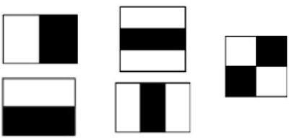

**The 5 Haar-like features are used for detecting faces.**

It typically performs about 20 stages of comparisons like this to decide if it is a face or not, but it must do this at each possible position in the image and for each possible size of the face, so in fact it often does thousands of checks per image. The name of this method is composed of two important words, Haar and Cascade. Haar belongs to Haar-like features which is a weak classifier and will be used for face recognition.

A Haar-like feature is a rectangle which is split into two, three or four rectangles. Each rectangle is black or white. This shows the different possible features. A Haar- cascade needs to be trained with various positive and negative pictures. The objective is to extract the combination of these features that represent a face. While a positive picture contains the object which must be recognized, a negative picture represents a picture without the object.

In the context of face detection, a positive picture possesses a face, and a negative picture does not. This machine learning requires grayscale pictures. The intensity of gray will be used to detect which feature is represented. These features can be found by calculating the sum of the dark pixels in an area subtracted by the sum of the bright pixels.

The 5 Haar-like features are used for detecting faces.

The basic principle in this method is based on are as follows:

• Images used in the integral representation that allows a machine to calculate the necessary object features.

• Using Haar-like features, the desired feature of the face can be found.

• Adaptive Boosting used to select the most suitable characteristics for the desired object to this part of the image.

• All the features are input to the classifier, which gives the result true or false.

The extracted combination of features from the training part will be used for detecting faces in a picture. To detect a face in an unknown picture is the combination of the features will be researched. The features are tried to be matched only in a block of pixels defined by a scale. Each feature of the combination will be tried to be matched one by one in the block. If one of the features does not appear in the block, the research in it will be stopped. The remaining features will not be tested because the machine concludes that there is no face in this block. Then, a new block is taken, and the process will be repeated.

The 5 Haar-like features used for detecting faces pixels with the researched combination in cascade which explains the second word in the name of the method. This method is efficient to detect an image without faces because only a few tests need to be run to infer that the image does not contain a face. A face is consequently detected when each feature of the combination has been recognized correctly in a block. We can see that the eyes are darker than the cheeks and the middle of the nose is brighter. All these features which were extracted from the training are used to find a pattern to represent a face. The process will proceed block by block until the last one. After checking the last block, the scale is increased, and the detection process starts again. The process is repeated several times with different scales to detect faces of different sizes. Only a few pixels are different between two neighbor blocks. Therefore, each time a face is detected in a picture, the same face is detected in different blocks.

All the detected faces that concern the same person are merged and are considered as one at the end of the entire process. The accumulation of these weak classifiers builds a face detector able to detect faces very fast with a suitable accuracy. A Haar- cascade classifier must be trained only once. Thus, it is possible to create one’s own Haar-cascade or use one which has already been trained.

**CHAPTER 5.**

**RESULTS AND DISCUSSIONS**

The users can interact with the system using a GUI. Here, users will be mainly provided with three different options such as student registration, faculty registration, and mark attendance.

• The students are supposed to enter all the required details in the student registration form. After clicking on the register button, the webcam starts automatically.

• The webcam will capture 50 images to create the image dataset and then terminate automatically.

• At the time of forming the image dataset, each student will get designated using an id number. While recognition, when the test student image matches with the dataset then the details of the student in the attendance excel sheet will be marked with a timestamp, if the test student image does not get matched with the dataset, then it will not be marked present, and all the unmatched students will be marked as absent after a certain period.

The following Images shows the nature of the system when it is fed with different size of datasets. Here we compare 3 groups of 2 data. Fig-8 depicts the comparison between recognition rate of the system with different camera angles. Fig-9 depicts the comparison between the training time and the number of images in the data set. And, finally, Fig-10 compares the recognition time it takes the system to recognize n number of faces.

For Left view, between,0 and 45 degrees the recognition rate is 99-100 percent. After 45 degrees the rate starts decreasing and goes to zero at 90 degrees angles. For Right view, between,0 and 45 degrees the recognition rate is 97-100 percent. After 45 degrees the rate starts decreasing and goes to zero at 90 degrees angles. And, for 0 degrees, the recognition rate is 100 percent.

The training period to train 10 images is 0.6 seconds, 50 images is 1.69 seconds, 100 images is 2.71seconds and 150 images is 3.67 seconds. The recognition time for a single

face is 1.1 seconds. Similarly, the recognition time for 3and 7 images is 1.4 and 1.8 seconds respectively. and the recognition time for 10 faces is approximately 2 seconds.

**5.1 USER INTERFACE REPRESENTATION (OF RESPECTIVE PROJECT)**

MANAGE SUBJECTS PANEL

**TEACHER WINDOW**

TIMETABLE PANEL

MANAGECLASSES 

TEACHER(LOGIN)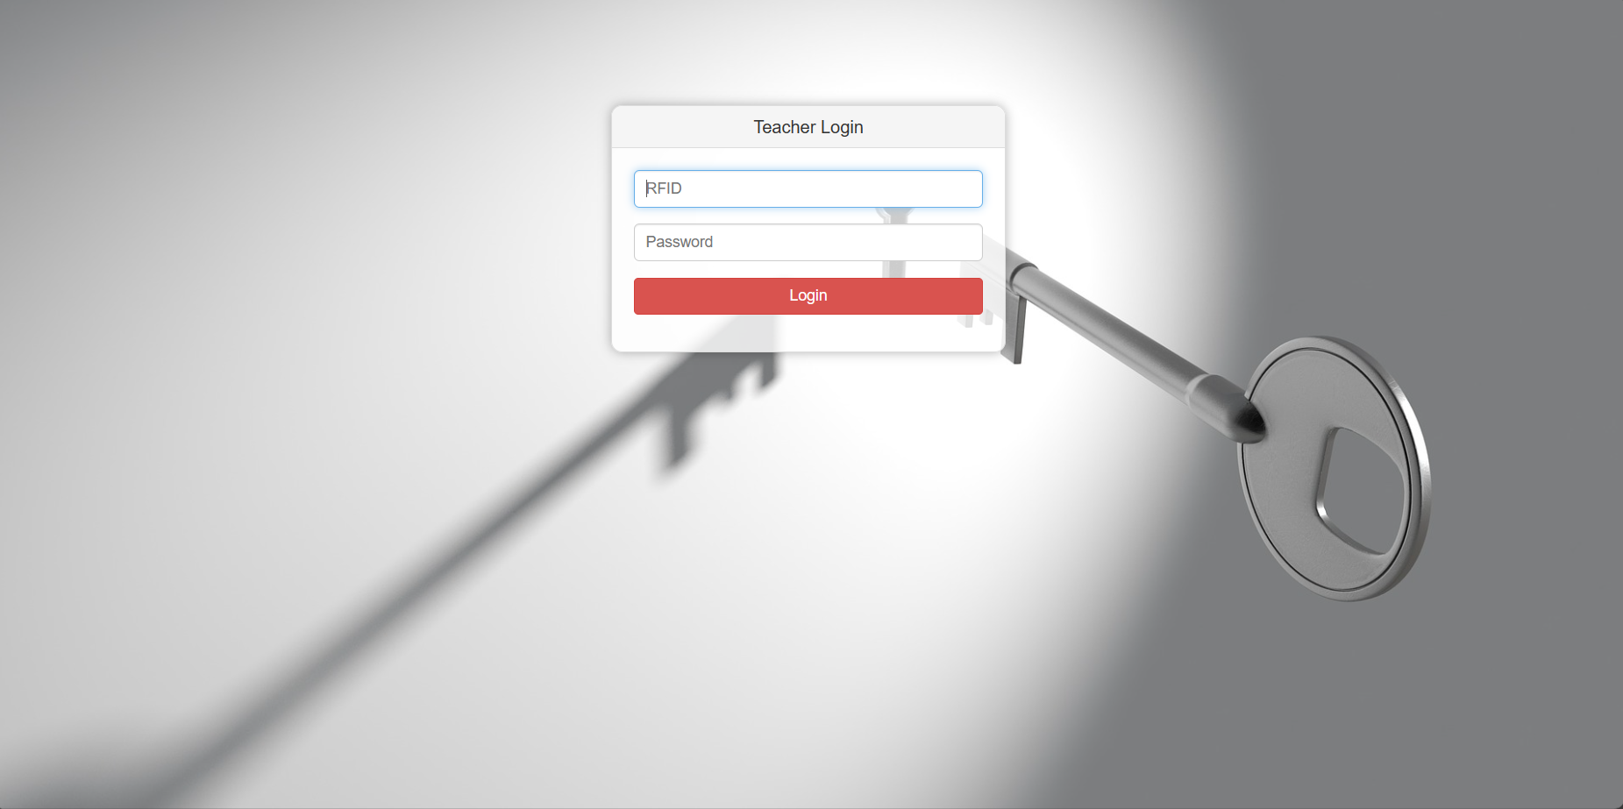ADMIN(LOGIN)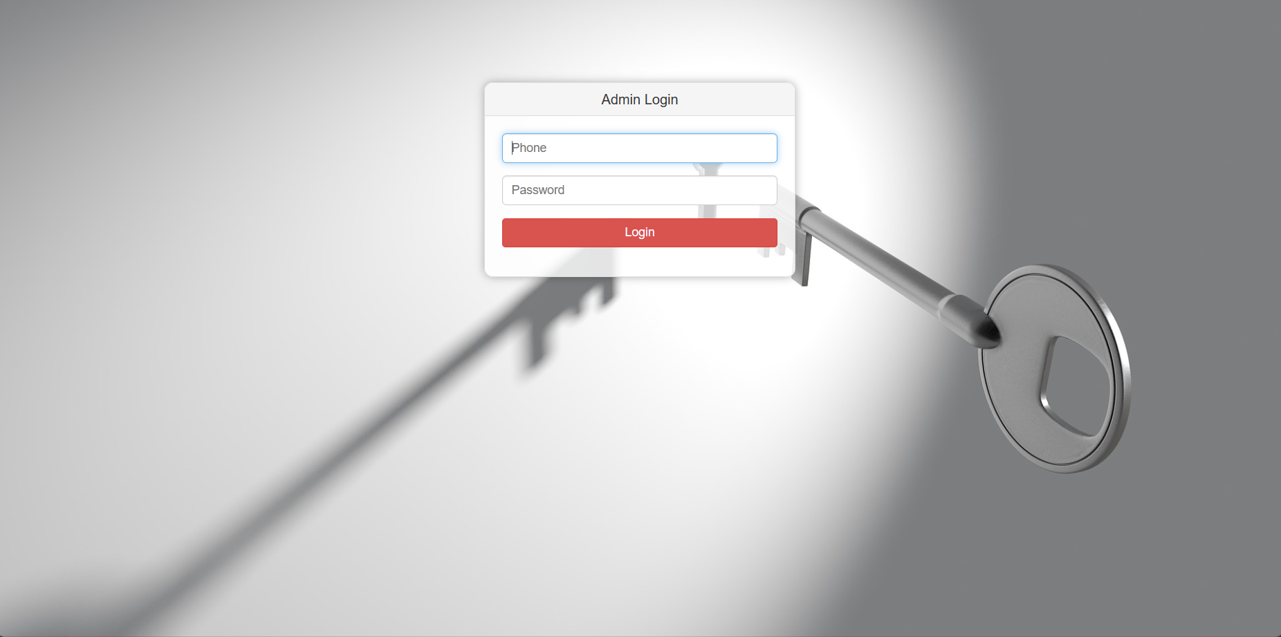

**5.1.1 BRIEF DESCRIPTION OF VARIOUS MODULES OF THE SYSTEM**

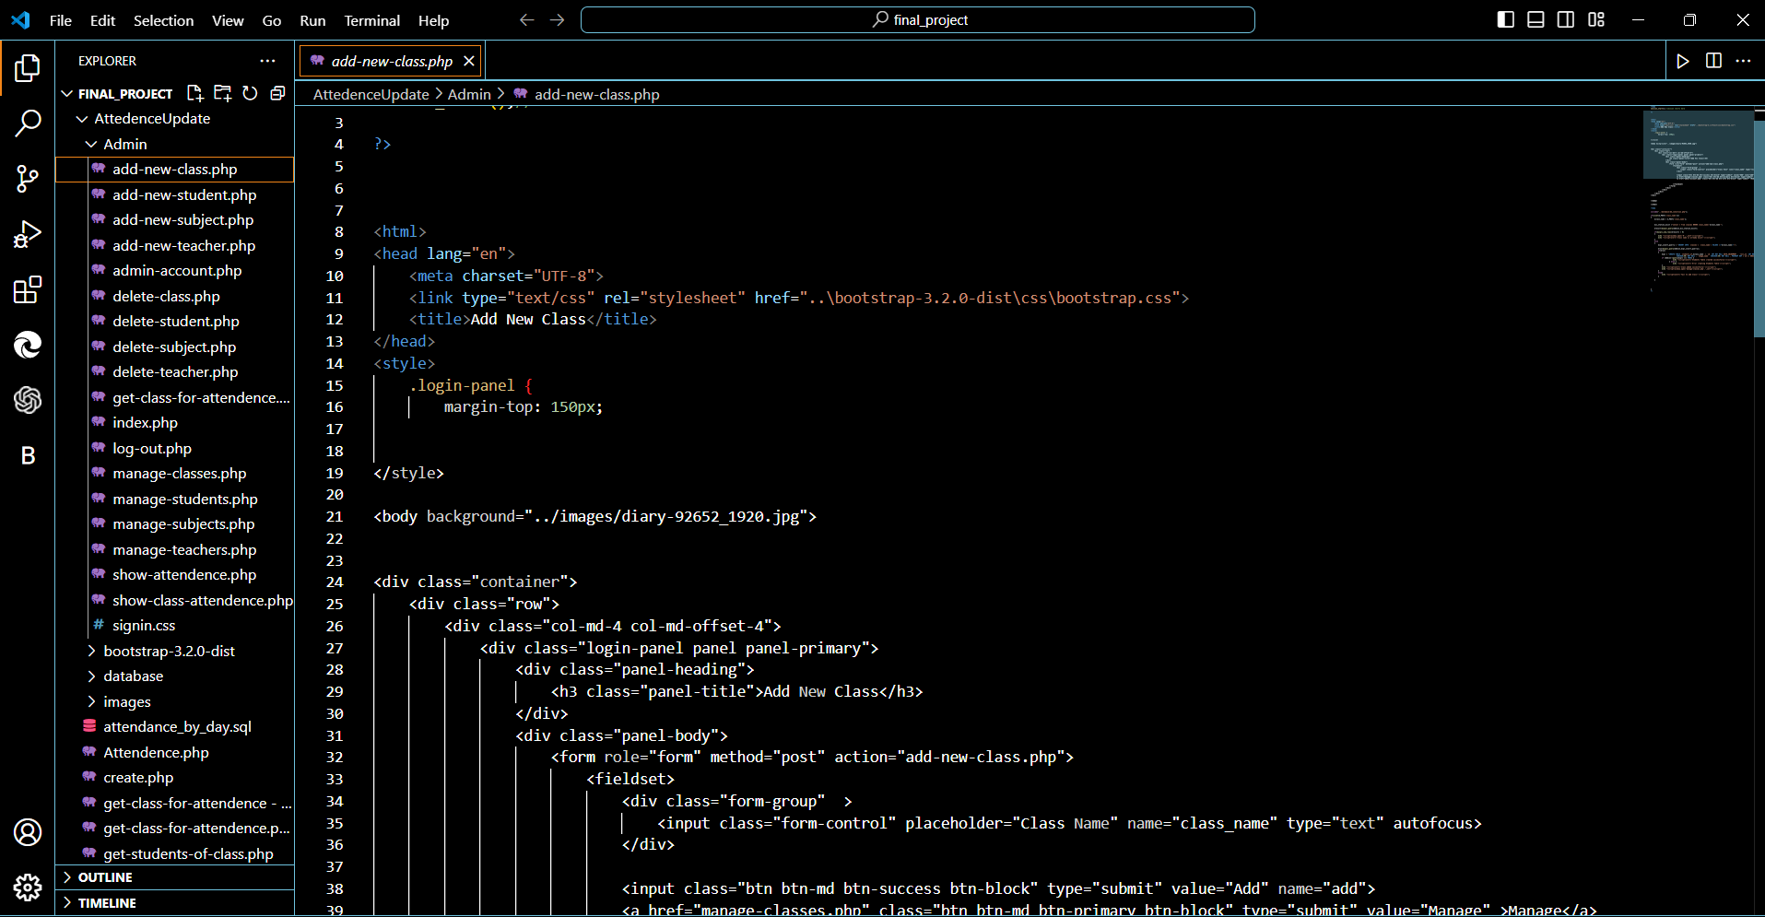

**FIG5.1 VARIETY OF MODULES IN THE SYSTEM**

5.2 **SNAPSHOTS OF SYSTEM WITH BRIEF DETAIL OF EACH**

**BACK-ENDS REPRESENTATION (DATABASE TO BE USED)**

STUDENTS(SCHEMA)

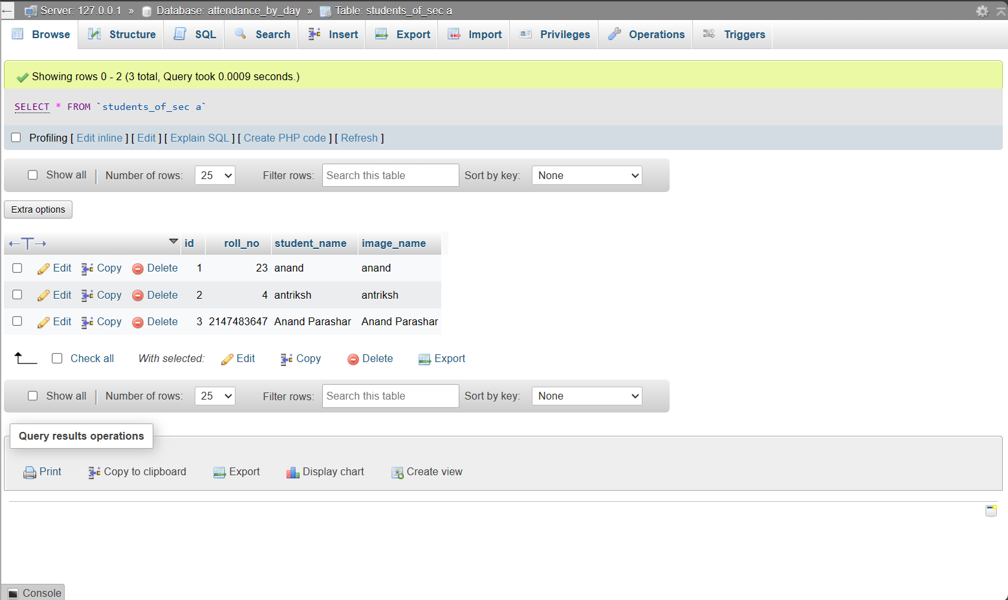

**CHAPTER 6.**

**CONCLUSION AND FUTURE SCOPE**

In this system, an attendance system is implemented for a lecture, section, or laboratory by which the lecturer or teacher can record students’ attendance. It saves time and effort, especially if there are a lot of pupils in the lecture. The goal of the automated attendance system is to minimize the shortcomings of the conventional (manual) approach. The application of image processing techniques in the classroom is demonstrated through this attendance system. This technique can enhance an institution's reputation in addition to simply assisting with the attendance system. The study also aims to highlight the project's enormous potential in the field of machine learning.

• The bad lighting in the classroom can occasionally have an impact on image quality, which negatively impacts system performance. This can be remedied in the latter stages by enhancing the video quality or employing algorithms.

• Advanced processors can be used to improve processing time of images.

• GSM can be used to send attendance details of students to their respective parents.

• The GUI can be made more interactive by allowing students to check their attendance details with necessary limitations.

**REFERENCES Year wise sort**

1. Shreyak Sawhney, Karan Kacker, Samyak Jain, Shailendra Narayan Singh , Rakesh Garg, “Real-Time Smart Attendance System using Face Recognition Techniques”, 2020
2. Naman Gupta, Purushottam Sharma, Vikas Deep, Vinod Kumar Shukla, “Automated Attendance System Using OpenCV”, 2019
3. Krishna Mridha, Nabhan Tawjih Yousef, “Study and Analysis of Im- plementing a Smart Attendance Management System Based on Face Recognition Technique using OpenCV and Machine Learning”, 2021
4. Organization, S. D. I. W. C., Kuster, B. (2018). Face Detection and Face Recognition in Python Programming Language. The Seventh International Conference on Informatics and Applications (ICIA2018).
5. Emami, Shervin Suciu, Valentin. (2012). Facial Recognition using OpenCV. Journal of Mobile, Embedded and Distributed Systems.
6. Heusch, G., Rodriguez, Y., Marcel, S.: Local Binary Patterns as an Image Preprocessing for Face Authentication. In: Proc FGR 2006, pp. 9–14 (2006)
7. Zhang, G., Huang, Z., Li, S.Z.: Boosting local binary pattern (LBP)-based face recognition. In: SinoBiometrics 2004, pp. 179–186 (2004)
8. Beveridge, J.R., Bolme, D., Teixeira, M., Draper, B.: The CSU Face Identification Evaluation System User’s Guide: Version 5.0, Technical Report, C.S. Dept., CSU (2003)
9. Messer, K., Matas, J., Kittler, J., Jonsson, K.: XM2VTSDB: The extended M2VTS database. In: Akumuri, S., Kullman, C. (eds.) AVBPA’99, pp. 72–77 (1999)
10. Messor, K., Kittler, J., Short, J., Heusch, G., Cardinaux, F., Marcel, S., Rodriguez, Y., Shan, S., Su, Y., Gao, W., Chen, X.: Performance Characterisation of Face Recognition Algorithms and Their Sensitivity to Severe Illumination Changes. In: ICB2006, pp. 1–11 (2006)
11. Philips, P.J., Moon, H.J., Rizvi, S.A., Rauss, P.J.: The FERET Evaluation Methodology for Face Recognition Algorithms. PAMI 22(10), 1090–1104 (2000)
12. Belhumeur, P.N., Hespanha, J.P., Kriegman, D.J.: Eigenfaces vs. Fisherfaces: Recognition using Class Specific Linear Projection. In: Buxton, B.F., Cipolla, R. (eds.) ECCV 1996. LNCS, vol. 1065, pp. 45–56. Springer, Heidelberg (1996)
13. Shan, S., Zhang, W., Su, Y., Xhen, X., Gao, W.: Ensemble of Piecewise FDA based on Spatial Histogram of Local (Gabor) Binary Patterns for Face Recognition. In: ICPR (2006)
14. Ahonen, T., Hadid, A., Pietikäinen, M.: Face description with local binary patterns: Application to face recognition. PAMI 28(12), 2037–2041 (2006)
15. Ojala, T., Pietikäinen, M., Mäenpää, T.: Multiresolution Gray-Scale and Rotation Invariant Texture Classification with Local Binary Patterns. PAMI 24(7), 971–987 (2002)
16. Zhang, W., Shan, S., Zhang, H., Gao, W., Chen, X.: Multi-resolution histogram of local variation patterns (MHLVP) for Robust Face Recognition. In: Kanade, T., Jain, A., Ratha, N.K. (eds.) AVBPA 2005. LNCS, vol. 3546, pp. 937–944. Springer, Heidelberg (2005)
17. Huang, X., Li, S.Z., Wang, Y.: Jensen-Shannon Boosting Learning for Object recognition. In: Proceeding of CVPR (2005)
18. Raja, Y., Gong, S.: Sparse Multiscale Local Binary Patterns. In: Proc. 17thBMVC (2006)
19. Rodriguez, Y., Marcel, S.: Face authentication using adapted local binary pattern histogram. In: Leonardis, A., Bischof, H., Pinz, A. (eds.) ECCV 2006. LNCS, vol. 3954, pp. 321–332. Springer, Heidelberg (2006).

20.Yuvaraj, C. Srikanth, M. Kumar, V. Srinivasa Murthy, Y.V. Koolagudi, Shashidhar. (2017). An approach to maintain attendance using image processing techniques. 1-3. 10.1109/IC3.2017.8284353.

[7] Nirmalya Kar, Mrinal Kanti Debbarma, Ashim Saha, and Dwijen Rudra Pal. Study of Implementing Automated Attendance System Using Face Recognition Technique. International Journal of Computer and Commu-nication Engineering, Vol. 1, No. 2, July 2012.

[8] Suma S L, Sarika Raga, “Real Time Face Recognition of Human Faces by using LBPH and Viola Jones Algorithm,” International Journal of Scientific Research in Computer Science and Engineering, Vol.6, Issue.5, pp.6-10, 2018.